

State space model input response

10*[1 1 0 0]
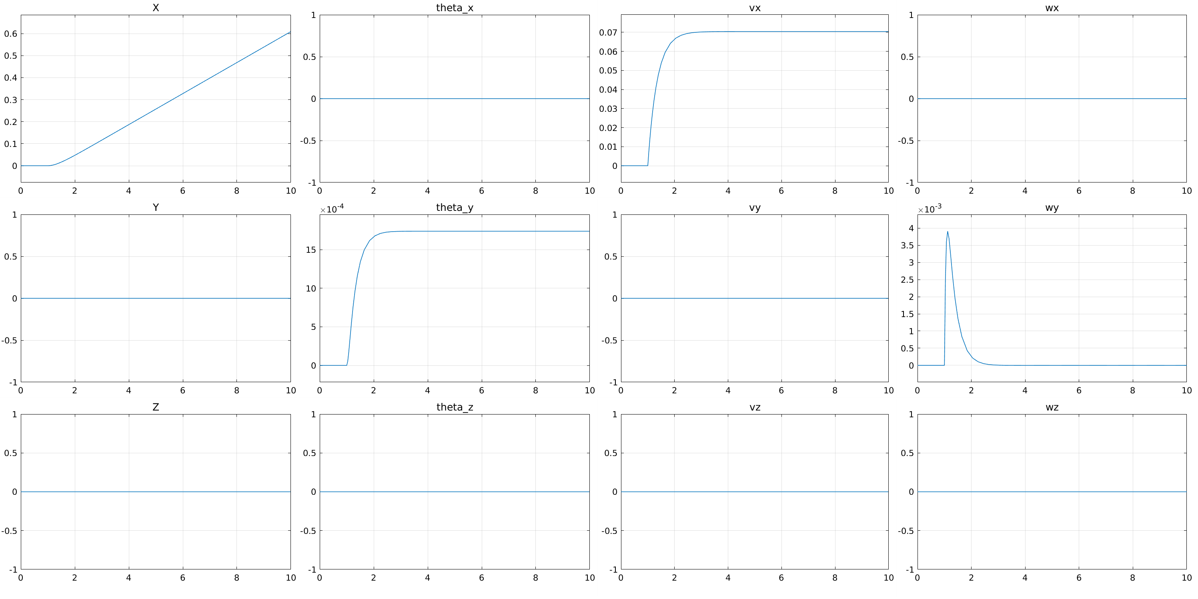
10* [0 0 1 1] – seems reasonable since thrusters are mounted slightly be origin

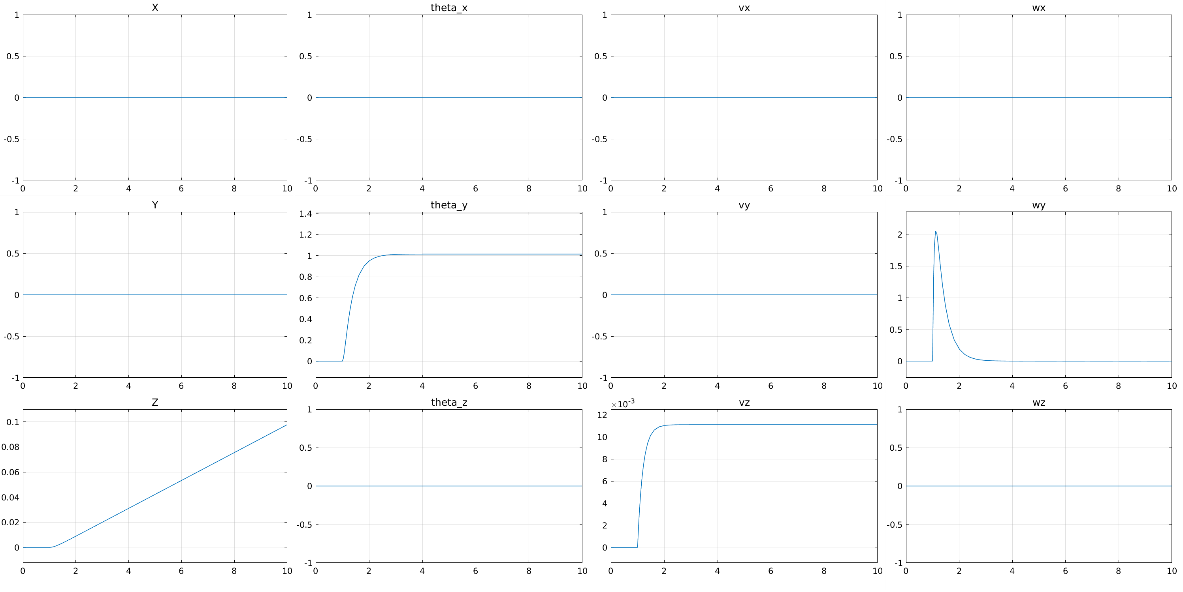

10*[0 0 1 -1]'
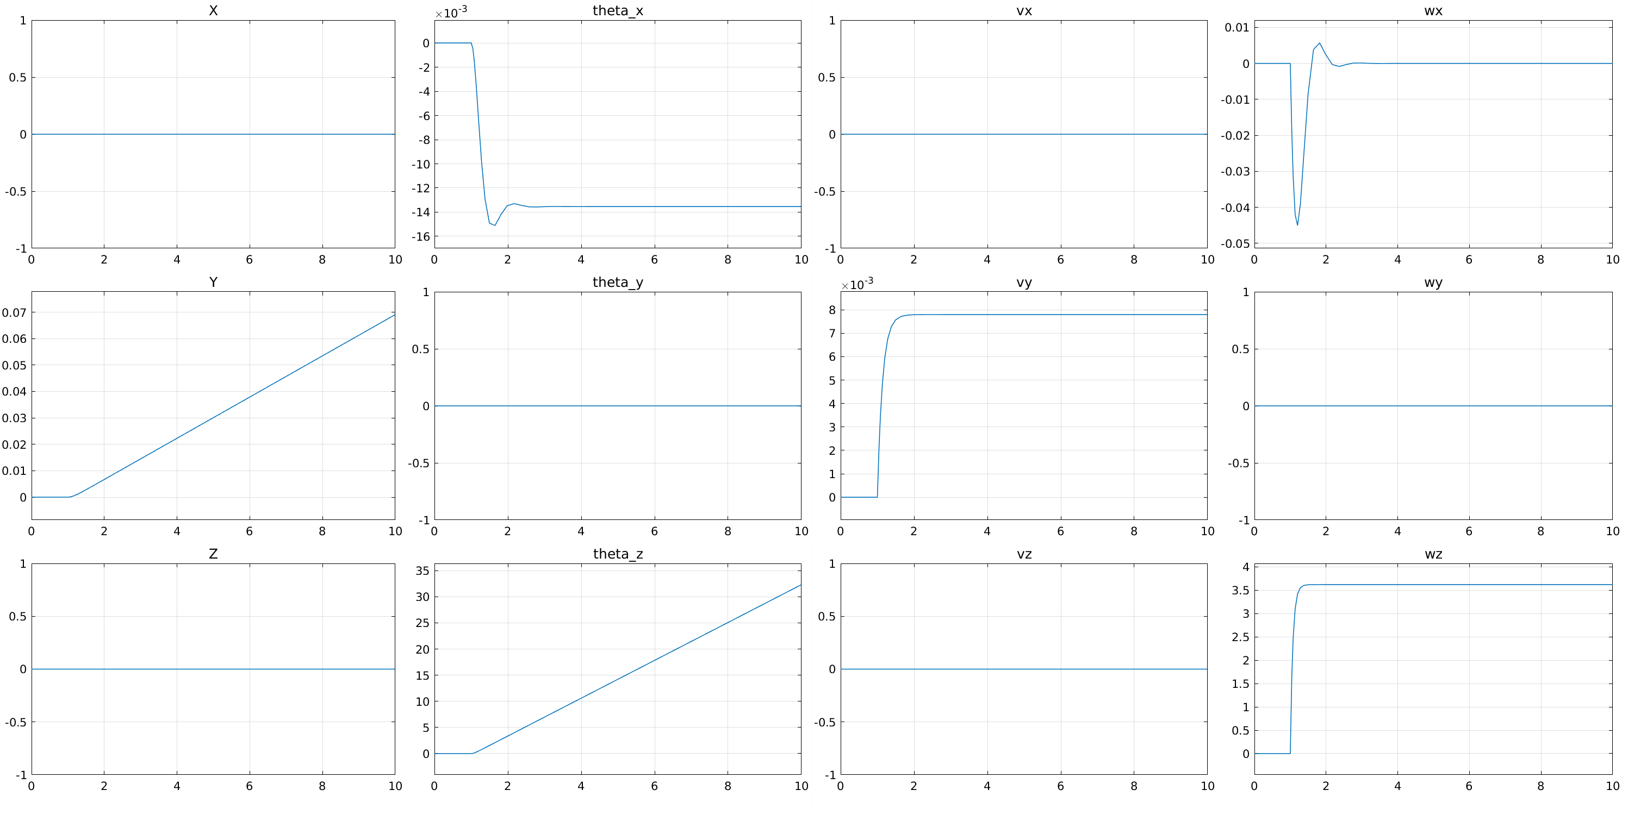
10*[0 0 -1 1]'

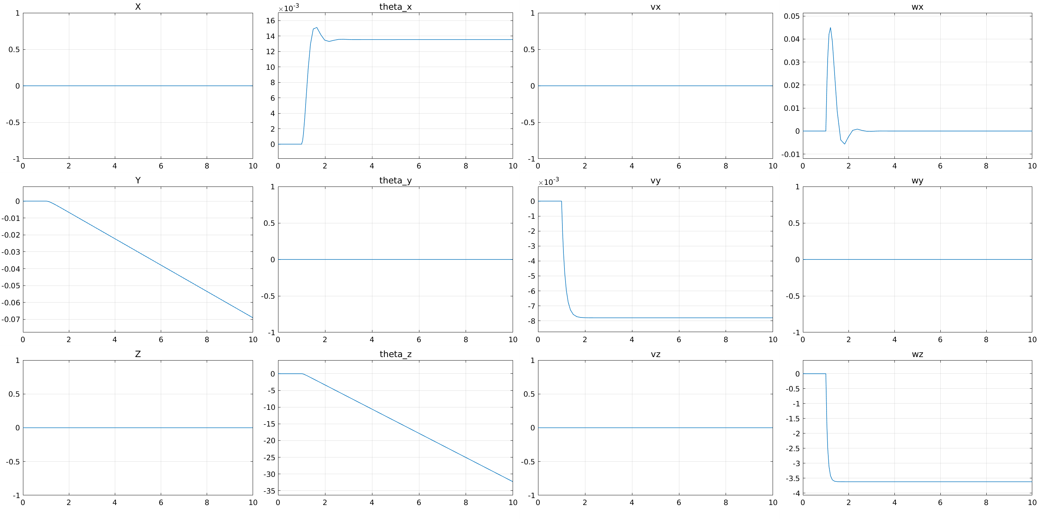
10*[-1 -1 0 0]
